
Introductions of webmaster and builder
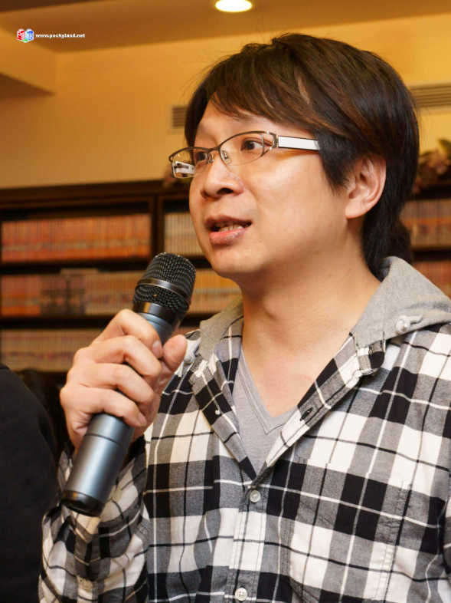
Founder and Administer of forum
id: POCKY
age: 39
occupation: Traditional cloth merchants
lego years: 30
Interest: Castle，Military

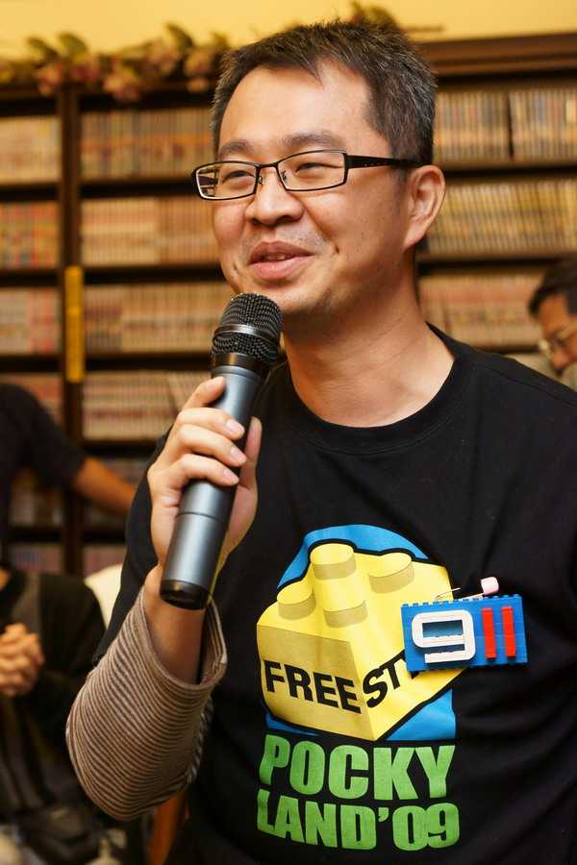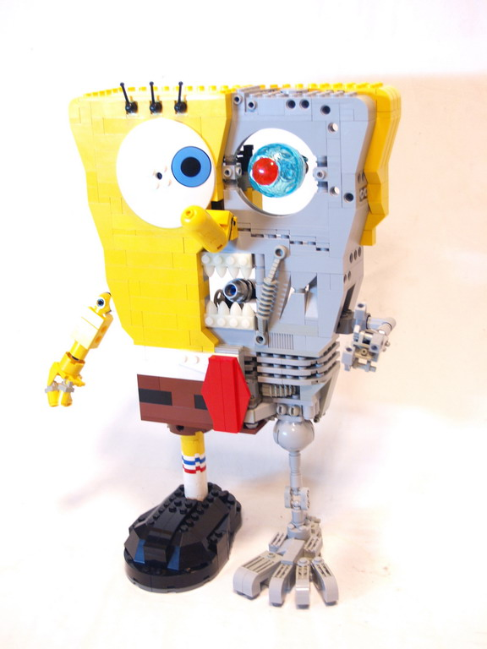
Lego Ambbssador & Administer of Forum
id:Rack Huang
age:37
occupation: Doctor
lego years:8 year
Interest: Mecha City Space Military.
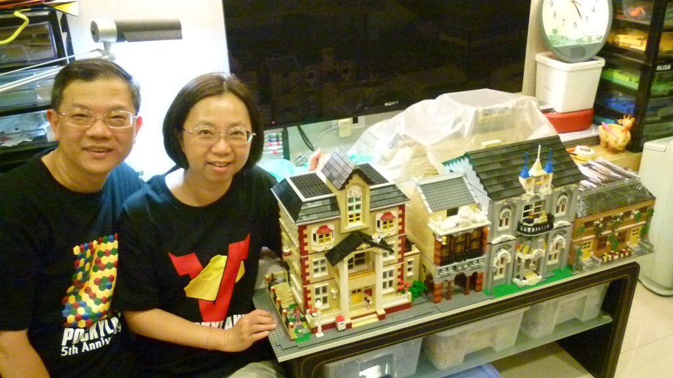
Webmaster of city
id:小高(kao)Married couple
age:49
occupation: Computer Engineer
lego years:7 year
Interest: City


id:企鵝逛大街(Jack)
age: 22
occupation: college student
lego years: 10 year
Interest: MOC different Series


id:我要埋玩舉 I want to buy toys
age:30
occupation: Education
lego years:2
Interest:Castle


id:便當豬 Lunch Pigage: 17occupation: Student
lego years:10 yearInterest: Castle

